NAME: VIGNESHWAR.D
REG.NO: 192524415
COURSE: CSA1515-Cloud Computing

EXPERIMENT 9
Hospital Information System using Zoho Creator (SaaS)

AIM:
To create a simple cloud based hospital Information System for SIMATS Hospital Using Zoho Creator , a Saas Platform.

IMAGES:
Dashboard:
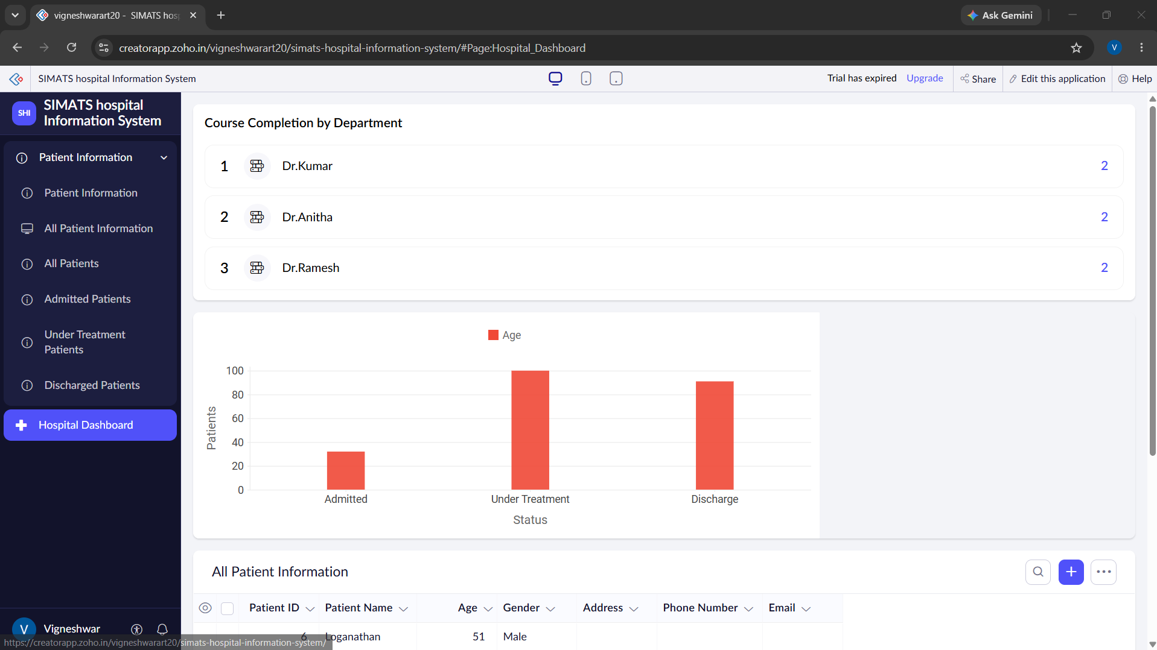

FORM:
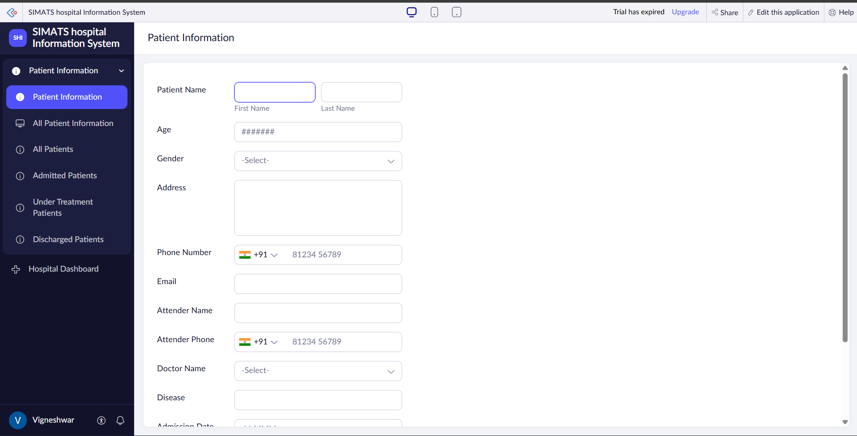
REPORT: 

